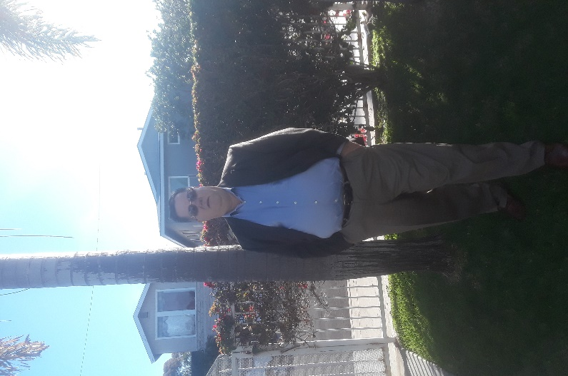

Corporal William S. Godfrey
United States Marine Corps

My name is William S. Godfrey, I was born in Detroit Michigan on August 13th 1963. I attended Parochial school until 1980. I joined the Marine Corps on October !0th 1980 and attended boot bootcamp at MCRD San Diego. On completion of bootcamp I was assigned to 3rd Battalion 5th Marines H&S Communication Platoon. I was assigned as a Field Wireman. While I served with 3/5, I was deployed to Okinawa Japan, Pohang South Korea and the Philippines. I reenlisted in 1983 and was attached the 5th Marine Regiment. I then attended Hawk Missile School at Fort Bliss Texas. I then returned to the 1st Marine Division and was assigned to 1st Reconnaissance Battalion as a Wire Chief. I was honorably discharged on 07/30/1985. While in the Marine Corps I was awarded the Good Conduct Ribbon, Overseas Deployment Ribbon. I obtained MOS 2512 Field Wireman, 7222 Hawk Missile Operator and 0321 Reconnaissance Marine.
I attended Montana State University Northern, located in Haver Montana and obtained a Bachelor of Science in Automotive Theory. I worked with Ford Motor Company as a Regional Service Representative, and then was promoted as Regional Director for Automotive training. Since then I have worked in the Automotive Service Management Industry until January of 2016.
I was recently appointed to the position as the Deputy Vice President, Central Region. with the First Marine Division Association.
I currently live in Chula Vista, California and will be moving to Los Lunas, New Mexico in March of 2021. At this time, I am running for reelection for the position as Deputy Vice President for the Central Region

